Experiment: House Price Prediction using Machine Learning
Aim
To implement a House Price Prediction model in Python using an appropriate machine learning algorithm and predict the price of a house based on its features.
For this experiment, we use Linear Regression because house price is a continuous numerical value.
Procedure
- Import the required Python libraries.
- Create a house-price dataset.
- Select input features such as area, number of bedrooms, bathrooms, and age of the house.
- Separate the input features X and target variable y.
- Split the dataset into training and testing data.
- Create a Linear Regression model.
- Train the model using the training dataset.
- Predict house prices using the testing dataset.
- Calculate Mean Squared Error (MSE) and R² Score.
- Give the details of a new house and predict its price.
Python Program
import pandas as pd
from sklearn.model_selection import train_test_split
from sklearn.linear_model import LinearRegression
from sklearn.metrics import mean_squared_error, r2_score
# Create House Price Dataset
data = {
"Area": [1000, 1200, 1500, 1800, 2000,
2200, 2500, 1300, 1600, 1900,
1100, 1400, 2100, 2300, 1700],

"Bedrooms": [2, 2, 3, 3, 4,
4, 4, 3, 3, 4,
2, 3, 4, 4, 3],

"Bathrooms": [1, 2, 2, 2, 3,
3, 3, 2, 2, 3,
1, 2, 3, 3, 2],

"Age": [20, 18, 15, 12, 10,
8, 5, 14, 11, 7,
22, 16, 9, 6, 13],

"Price": [2500000, 3000000, 4000000, 4800000, 6000000,
6800000, 8000000, 3500000, 4300000, 5800000,
2700000, 3800000, 6500000, 7500000, 4500000]
}

# Create DataFrame
df = pd.DataFrame(data)
print("======================================")
print(" HOUSE PRICE PREDICTION")
print("======================================")

print("\nDataset:")
print(df)

# Input features
X = df[["Area", "Bedrooms", "Bathrooms", "Age"]]
# Target variable
y = df["Price"]
# Split dataset
X_train, X_test, y_train, y_test = train_test_split(
X, y, test_size=0.3, random_state=42
)

# Create Linear Regression model
model = LinearRegression()

# Train model
model.fit(X_train, y_train)

# Predict test data
y_pred = model.predict(X_test)

print("\nActual House Prices:")
print(y_test.values)

print("\nPredicted House Prices:")
print(y_pred)

# Calculate MSE
mse = mean_squared_error(y_test, y_pred)

# Calculate R2 score
r2 = r2_score(y_test, y_pred)

print("\nMean Squared Error:")
print(mse)
print("\nR2 Score:")
print(r2)
print("\nR2 Score Percentage:")
print(r2 * 100, "%")

# Predict price of a new house
new_house = pd.DataFrame({
"Area": [2000],
"Bedrooms": [3],
"Bathrooms": [2],
"Age": [5]
})
predicted_price = model.predict(new_house)

print("\nNew House Details:")
print("Area = 2000 sq.ft")
print("Bedrooms = 3")
print("Bathrooms = 2")
print("Age = 5 years")

print("\nPredicted House Price:")
print(predicted_price[0])
Sample Output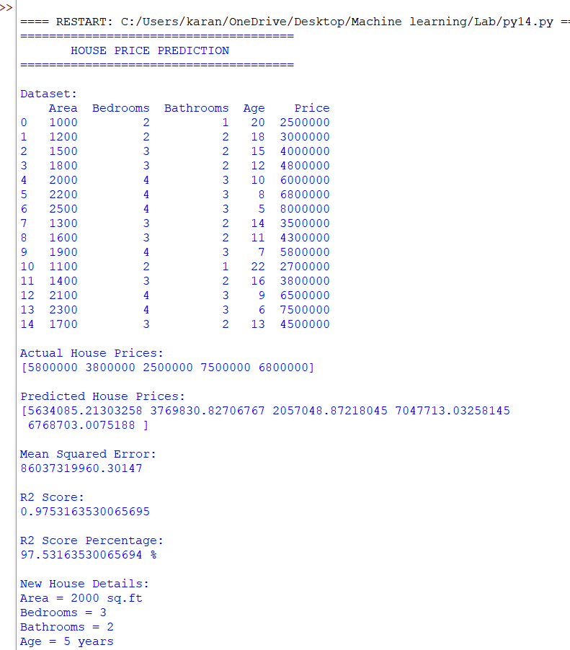
Result
The House Price Prediction Model was successfully implemented using the Linear Regression algorithm. The model was trained using house features such as area, number of bedrooms, number of bathrooms, and age of the house, and was used to predict the price of a new house.

